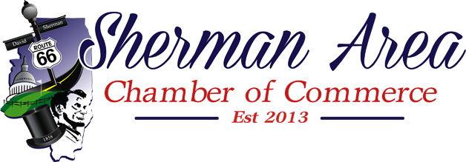
Tentative Executive Board Agenda
February 6, 2019 at 11:30 am
Sherman Public Library

- Welcome & Introductions
  - Roll Call
  - Set the Agenda
- Old Business
  - Secretary
    - Approval of Minutes
  - Treasurer
    - Account Reports
    - Checking Account Signatures
  - Executive Assistant Report
- Old Business
  - VIP/Honoraria Member
  - AED Donation
  - Events
    - February 7, Member Breakfast
    - March 7, Meet the Candidates Forum
- New Business
  - Ed Legner reviewing Insurance Coverage
- Items added to the agenda
- Adjourn
  - Next scheduled meeting is in March 6, 2019 for 11:30am at the Sherman Public Library. Members and the public are encouraged to attend.

