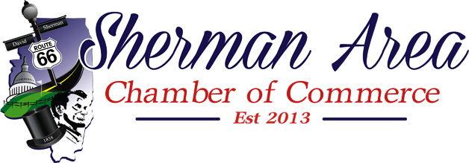
Tentative Executive Board Agenda
January 2, 2019 at 11:30 am
Sherman Public Library

- Welcome & Introductions
  - Roll Call
  - Set the Agenda
  - Introductions
- Old Business
  - Secretary
    - Approval of Minutes
  - Treasurer
    - Account Reports
    - Checking Account Signatures
  - Executive Assistant Report
- New Business
  - SACC Board Position Openings
  - VIP/Honoraria Member Nominations
  - Donation
  - Events
    - February 7, Member Breakfast
      - SACC Coordinator: ?
      - Location: Farm Credit
      - Presenter: Sonya Jones
      - Caterer: ?
    - March 7, Meet the Candidates Forum
      - SACC Coordinator: ?
      - Location: UCB Community Center (need to confirm)
      - Presenters: Moderator, 2 mayoral, 6? trustee timeslots (invite, provide rules, confirm)
      - Caterer: ? (light refreshments) Do we just provide coffee, water, cookies?
- Items added to the agenda
- Adjourn
  - Next scheduled meeting is in March 6, 2019 for 11:30am at the Sherman Public Library. Members and the public are encouraged to attend.

Breakfast Agenda
7:00 - Breakfast Begins Staff
7:20 – 7:30 Welcome & Introductions Sean Bull
7:30 – 8:00 Speaker Sonya Jones
8:00 – 9:00 Networking/Adjourn Sean Bull
……………………………………………………………………………………………………………………………………………………..
March 7, Meet the Candidates Forum
March 7, 2019
UCB Community Center, 120 Illini Drive, Sherman
Forum Starts at 6:00 pm Promptly
Location: UCB Community Center (need to confirm)
Time:?
Candidates for Village President (Mayor) and Village Trustees (2) (invite, provide rules, time allotment, Q&A slot? confirm)
Caterer (light refreshments): ?
SACC Coordinator:
SACC Moderator: Sean Bull
For Mayor: Trevor J. Clatfelter (Incumbent)
Tracy Shaw
Village Trustee: Jay Timm (Incumbent)
Brian Long (Incumbent)
Josh Carter
Vicky Jenkins?

Time start? Amount of time per candidate? Format used?

